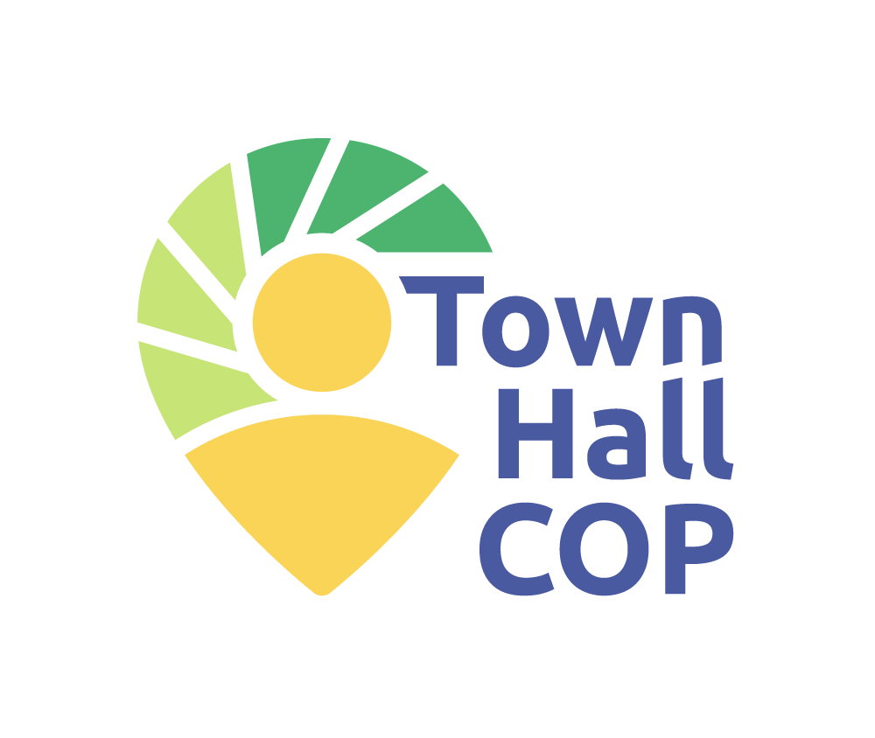
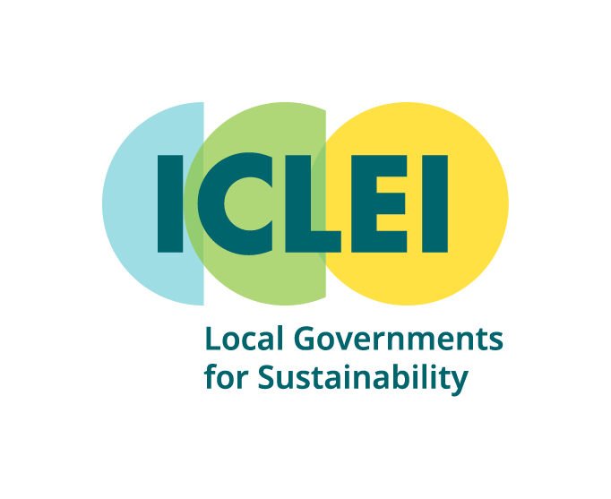
Town Hall COP National Government Outreach Letter Templates

English language

Instructions for using the Town Hall COP national government outreach letter templates
These letter templates are designed to support your outreach to national government representatives as part of the Town Hall COP Initiative.
To send your letter:
- Identify the appropriate recipients.
We recommend sending the letter to:
  - The ministry or department responsible for climate policy or coordination of the NDC (e.g., Ministry of Environment, Ministry of Climate, Ministry of Planning or Energy)
  - If relevant, also copy the Ministry of Urbanization (or equivalent Ministry), your country’s UNFCCC focal point or CHAMP contact (if your country is part of the CHAMP initiative).
- Customize the yellow-highlighted fields in the letter.
These include key details about your Town Hall COP and contact information.
- Add a personal touch.
If your city or region already has a working relationship with national ministries, add a note to acknowledge past collaboration.
- Send the letter via email and/or official correspondence channels.
Include the letter as a signed PDF, Word document or paper document, depending on regular practices. You may also attach your Town Hall COP report or photos if available.
- Follow up.
A phone call, short email, or invitation to a follow-up meeting can help ensure your outreach is seen and appreciated.
Available letter template versions:
- Version 1 – Pre-NDC Submission: For countries still preparing their NDC 3.0. Encourages early engagement with an invitation and offers local inputs.
- Version 2 – Post-NDC Submission: For countries that have already submitted NDC 3.0. Focuses on how Town Hall COPs can support implementation.
- Version 3 – Post-Event (Pre-NDC): To send after the Town Hall COP. Share outcomes for consideration in the upcoming NDC.
- Version 4 – Post-Event (Post-NDC): To send after the Town Hall COP. Share outcomes to support national implementation of the NDC.

VERSION 1 Invitation to national government representatives of national governments that have yet to submit their updated NDC
Subject: Invitation to engage with our Town Hall COP and support NDC Alignment
[Date]
Dear [Recipient Name],
My name is [Name], the [Position] of [Organization Name], and I am writing to inform you of our community’s intention to host a Town Hall COP, and to invite your Ministry’s engagement in this important initiative.
Town Hall COPs are community-driven events that aim to connect transformative local climate priorities to national and global action. Inspired by the structure of the UN Climate Change Conferences (COPs), they bring together local stakeholders – including government officials, civil society, businesses, youth, Indigenous Peoples, and other community actors – to discuss climate goals, assess progress, and identify locally grounded pathways for enhancing climate action aligned with national priorities.
This initiative aligns closely with recent international mandates. The outcomes of COP28 (para. 161) urges Parties and non-Party stakeholders to join efforts to accelerate delivery through inclusive, multilevel, gender-responsive and cooperative action. This is not just a recommendation – it affirms that national governments have a responsibility to implement multilevel climate action.
The Town Hall COP Initiative responds directly to this call by providing a structured, participatory model for multilevel dialogue and co-creation of climate solutions. It also answers the COP30 Presidency’s call for a Global Mutirão – a powerful mobilization rooted in Brazilian culture. Mutirão refers to a spontaneous, community-driven effort where people come together to meet urgent needs through collective, self-determined action. Town Hall COPs are a concrete embodiment of this spirit, bringing climate action to the doorstep of every community and ensuring their voices are heard at the national and global level.
Town Hall COPs also provide valuable support to the implementation of the the COP28 Coalition for High Ambition Multilevel Partnerships (CHAMP) for Climate Action and endorsed by 75 countries as of 2025 is one of the leading efforts to support national governments in the delivery of this commitment for multilevel action.
As your Ministry prepares to submit an updated Nationally Determined Contribution (NDC 3.0) to the UNFCCC ahead of COP30 in Belém, Brazil, we believe our Town Hall COP can contribute valuable local insights and recommendations to support an ambitious and just national plan. Specifically, the event will:
- Translate national climate priorities into community-level conversations that engage and inform local stakeholders;
- Highlight replicable innovations and existing action at the local level that can be scaled or supported through national mechanisms;
- Generate concrete suggestions on how national policy and resources can better enable subnational implementation.
We are committed to sharing the outcomes of our Town Hall COP with your team, including a summary of local priorities and suggested pathways for national-subnational alignment. We would also be honored to welcome a representative from your Ministry to join us – either as a speaker or observer – and to explore opportunities for collaboration.
We look forward to coordinating with you and contributing to this shared multilevel journey toward a more climate-resilient and inclusive future.
Sincerely,
[Your Name]
[Title]
[Local Government Name]
[Email / Phone]

VERSION 2 Invitation to national government representatives of national governments that have submitted their updated NDC
Subject: Invitation to collaborate on NDC implementation through our Town Hall COP
[Date]
Dear [Recipient Name],
My name is [Name], the [Position] of [Organization Name], and I am writing to share that our community in [City/Region Name] will host a Town Hall COP, and to invite your Ministry’s engagement as we work to support the implementation of the national climate plan.
Town Hall COPs are locally-convened, community-led events that strengthen connections between local realities and national climate priorities. They provide inclusive spaces where a broad cross-section of local stakeholders – including government, youth, business, civil society, Indigenous Peoples, and others – can review local climate progress, identify implementation challenges and opportunities, and shape locally grounded contributions to national and global climate action.
We understand that our national government has already submitted its updated Nationally Determined Contribution (NDC 3.0) ahead of COP30. With this milestone achieved, our Town Hall COP is designed to help translate that ambition into action on the ground by:
- Engaging residents and local institutions in understanding the new NDC and their role in delivering it;
- Identifying local programs and solutions that can contribute to NDC targets across mitigation, adaptation, resilience, and just transition priorities;
- Offering insights on where additional support, policy clarity, or coordination could help strengthen local delivery.
This approach echoes the COP28 outcomes (para. 161), which urges Parties to accelerate climate delivery through “inclusive, multilevel, gender-responsive and cooperative action.” In this spirit, we see our Town Hall COP as an important channel for collaborative implementation, rooted in real community experience.
Furthermore, our efforts align with the COP30 Presidency’s call for a Global Mutirão - a nationwide mobilization rooted in Brazilian culture that celebrates bottom-up, collective climate action. Town Hall COPs are a concrete manifestation of this mutirão spirit: organic, community-driven, and anchored in self-determined local action in support of broader national and international goals. Town Hall COPs also provide valuable support to the implementation of the the COP28 Coalition for High Ambition Multilevel Partnerships (CHAMP) for Climate Action and endorsed by 75 countries as of 2025 is one of the leading efforts to support national governments in the delivery of this commitment for multilevel action.
We are committed to sharing the outcomes of our event with your Ministry, including key messages from local stakeholders, potential contributions to the NDC’s implementation, and ideas for strengthened multilevel collaboration. We would also welcome the participation of a Ministry representative at the event, should someone be available to join.
We hope this invitation opens the door to deeper partnership, and we remain at your disposal to discuss how this Town Hall COP can support the implementation of our shared climate commitments.
Sincerely,
[Your Name]
[Title]
[Local Government Name]
[Email / Phone]

VERSION 3 Sharing of Town Hall COP outcomes to national government representatives of national governments that have yet to submit their updated NDC
Subject: Outcomes from Our Town Hall COP: Contributions to NDC Development
[Date]
Dear [Recipient Name],
My name is [Name], the [Position] of [Organization Name], and I am writing to follow up on the successful completion of our Town Hall COP, hosted in [City/Region Name] on [Date]. This event brought together a diverse group of local stakeholders – including government officials, youth, business leaders, Indigenous communities, and civil society representatives – for a community-driven dialogue on climate action.
As you may be aware, Town Hall COPs are a global initiative led by ICLEI – Local Governments for Sustainability, designed to connect local climate priorities with national and international processes. These events are grounded in three core principles: they are community-led, nationally relevant, and transformation-oriented.
Our Town Hall COP responded to the COP28 outcomes (para. 161), which urges Parties to deliver climate action through inclusive, multilevel, gender-responsive and cooperative action. It also embodies the “Global Mutirão” spirit championed by the COP30 Presidency: a bottom-up, self-organized, collective effort to meet urgent climate needs. Town Hall COPs also provide valuable support to the implementation of the the COP28 Coalition for High Ambition Multilevel Partnerships (CHAMP) for Climate Action and endorsed by 75 countries as of 2025 is one of the leading efforts to support national governments in the delivery of this commitment for multilevel action.
We are pleased to share the following local outcomes and key messages that we respectfully submit for your consideration as your Ministry finalizes its NDC 3.0 submission ahead of COP30:

[INSERT KEY OUTCOMES AND RECOMMENDATIONS FROM THE TOWN HALL COP]

We believe these insights provide a valuable on-the-ground perspective that can strengthen the relevance, ambition, and equity of national climate commitments. We would welcome the opportunity to engage further on how local priorities can be reflected in your updated NDC.
Thank you for your continued leadership in advancing inclusive climate action.
Sincerely,
[Your Name]
[Title]
[Local Government Name]
[Email / Phone]

VERSION 4 Sharing of Town Hall COP outcomes to national government representatives of national governments that submitted their updated NDC
Subject: Outcomes from Our Town Hall COP: Contributions to NDC Implementation
[Date]
Dear [Recipient Name],
My name is [Name], the [Position] of [Organization Name]. Following the successful completion of our Town Hall COP in [City/Region Name] on [Date], I am writing to share the local priorities and proposals that emerged during this community-led event, and to explore how these insights can support your Ministry’s efforts to implement the recently submitted NDC.
The Town Hall COP Initiative, led by ICLEI – Local Governments for Sustainability, enables local communities to connect climate action at the ground level to national and international strategies. Each event is designed to reflect local realities, while engaging directly with national priorities—including those outlined in NDC 3.0.
Our event builds on the global call in COP28 outcomes para. 161 for inclusive, multilevel and cooperative action, and responds to the COP30 Presidency’s Global Mutirão campaign – grounded in collective, grassroots-led mobilization. Town Hall COPs also provide valuable support to the implementation of the the COP28 Coalition for High Ambition Multilevel Partnerships (CHAMP) for Climate Action and endorsed by 75 countries as of 2025 is one of the leading efforts to support national governments in the delivery of this commitment for multilevel action.
In that spirit, we are pleased to share the following outcomes and recommendations from our Town Hall COP, which we hope can support and enhance NDC implementation:

[INSERT KEY OUTCOMES AND LOCAL CONTRIBUTIONS TO IMPLEMENTATION]

These outcomes represent the voices of residents, community leaders, and organizations on the front lines of climate action. We believe they offer practical, scalable contributions to your national climate implementation efforts.
We would be glad to explore ways to align our next steps with national actions and would welcome continued collaboration with your Ministry.
Thank you for your attention and for your commitment to inclusive climate governance.
Sincerely,
[Your Name]
[Title]
[Local Government Name]
[Email / Phone]

